

FACULTY OF BUSINESS SCIENCES
DEPARTMENT OF INFORMATION AND MARKETING SCIENCES

NAME: CHISORO SIMBARASHE
REGISTRATION: R259880M
MODULE CODE: DSI143- FUNDAMENTALS OF DATA WAREHOUSE AND DATA MINING

PROGRAM: DATA SCIENCE AND INFORMATICS (HARARE WEEKEND CLASS)

ASSIGNMENT 1
LECTURER: K. CHINYONGO
REQUIREMENTS ANALYSIS
- Data Warehouse Development (Medallion Architecture)
- Objective: Build a SQL-based, non-historised (truncate/load) data warehouse integrating ERP and CRM CSV data using a Medallion (Bronze/Silver/Gold) framework.
- Data Quality & ETL: Clean, de-duplicate, and standardize raw data; implement robust ETL pipelines to transform data into a structured star schema.
- Deliverables: End-to-end documentation including architecture diagrams, data dictionary/catalog, naming conventions, and validation reports
- Business Intelligence and Analytics
- Objective: Develop analytical SQL queries against the Gold-layer star schema to drive decision-making.
- Key Areas: Generate actionable insights regarding:-
- Sales performance
- Customer behaviour
- Product trends.
Summary of Scope
Component | Focus
Sources | ERP and CRM CSV Files
Methodology | Medallion (Bronze - Silver - Gold)
Strategy | Current state (Truncate/Reload)
Output | Star Schema and Analytics

Data Management Approach
This is the design of how the data will flow and be consumed. In this project, we will design a Data Warehouse for reporting using the Medallion architecture. The Medallion Architecture is made up of three layers, namely: Bronze, Silver, and Gold, and at each layer, there is a separation of concerns. At the Bronze, we keep the original data as it is from the sources. We transform and clean data at Silver Layer. We build different types of objects for business intelligence and machine learning at the Gold Layer.
Layers of the Data Warehouse
 | BRONZE LAYER | SILVER LAYER | GOLD LAYER
Definition | Raw data | Clean and standardised data | Business Ready Data
Objective | For traceability and debugging | Prepared data for analysis | Provides data to be consumed for analytics
Object Type | Tables | Tables | Views
Load Method | Full-load (Truncate and Insert) | Full-load (Truncate and Insert) | None
Data Transformation | None (As-is) | Cleaning  Standardisation  Normalisation  Feature Engineering  Enrichment | Integration  Aggregation  Business logic and Rules
Data Modelling | As-is | As-is | Star Schema  Aggregation objects
Consumers | Data Engineers | Data Engineers  Data Analysts | Data Analysts  Business Intelligence
Medallion Architecture
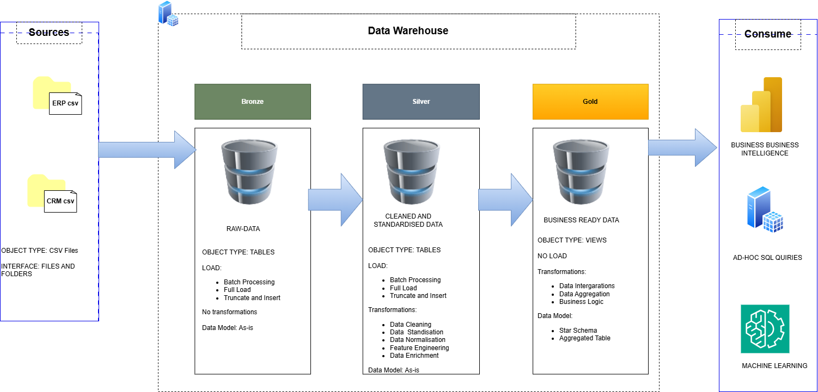

Naming Conversions
Naming conversions are set of rules or guidelines for naming anything in a project from:
- Database
- Schema
- Tables
- Procedures
In this project I will use the camelCase where the first word is lower case and upper case first letter of all subsequent words.
Language: English
Rule: Avoid using reserved words
Table Naming Conversions
Bronze Rules
- All table names must start with source name, and table names must match original tables renamed to match the camelCase.
- <source><entity>
  - <source>: Name of the source system (ERP,CRM)
  - <entity>: Original name of table renamed to match camelCase
  - Example: crmCustomerInfo – Customer information table from crm file.
Silver Rules
- All table names must start with source name, and table names must match original tables renamed to match the camelCase.
- <source><entity>
  - <source>: Name of the source system (ERP,CRM)
  - <entity>: Original name of table renamed to match camelCase
  - Example: crmCustomerInfo – Customer information table from crm file.
Gold Rules
- All table names must be meaningful business aligned names starting with category prefix.
- <category><entity>
  - <category>: The role of the table such as dimension (dim) or fact table (fact)
  - <entity>: Descriptive name of the table aligned with the business domain (customer, product, sales)
  - Example: factSales – Fact table containing sales information.
Column Naming Conversions
Surrogate Keys
- All primary keys in the dimension tables must use the suffix “Key”
- <tableName><Key>
  - <tableName> refers to the name of the table the key belongs to.
  - <Key> indicates that the column is a primary key.
  - Example: customerKey indicating the primary key from dimension table dimCustomers table.
Technical Columns
- All technical columns must be prefix by “dwh” followed by a descriptive name indicating the column’s purpose.
- dwh<ColumnName>
  - dwh: Prefix for system generated data
  - <CloumnName>: Descriptive name indicating column purpose
- Example: dwhLoadDate: System generated column indicating the date when the data was loaded.
Stored Procedures
- All load procedures must have a prefix ‘load’<LayerName>
- Example: loadBronze

